Alfred Abraham
CDS DX 799: Data Science Capstone
Dr. Von Korff
April 19th, 2026

Capstone Technical Report
Executive Summary
Phishing is a form of cyber-attack that utilizes fraudulent emails, websites, text messages, or phone calls to deceive people into sharing sensitive information, downloading malware or engage in other activities that expose them to harm online. There is a need to effectively detect phishing attempts so that people can avoid falling for them. Over the past few semesters, I explored three phishing-related datasets to understand how machine learning could be used for phishing detection. Two of the datasets contained phishing and legitimate URLs as well as the characteristics associated with these URLs (i.e. url length, presence of ip address) while the last contained phishing and safe emails.
After exploring the structure of all three datasets, I utilized five classification models that fell into each of these categories: linear models, distance-based models, tree models, ensemble models, and probabilistic models. The linear model, Logistic Regression, was used as a baseline to compare the others against. While all models aside from the probabilistic Bernoulli Naïve Bayes model got results that met or exceeded the 80% success criteria, only the ensemble model, Random Forest, consistently got results that approximated or exceeded those of the baseline model on all three datasets. Therefore, I recommend using both this model and the Logistic Regression model for phishing detection. However, before deploying these models, it is necessary to do preprocessing steps such as feature engineering and feature scaling as well as adjusting for the actual ratio of phishing and non-phishing samples in the real world. Once these steps are done, organizations and businesses are sure to improve their overall level of cybersecurity.
Introduction and Problem Definition
Phishing is a cyberattack that falls under the general umbrella of social engineering (IBM, 2024). Social engineering doesn’t directly target networks and resources but rather uses human error, deception, and pressure tactics to manipulate victims into unintentionally harming themselves and their organization. In the case of phishing, this involves using fraudulent emails, websites, text messages, or phone calls to trick people into sharing sensitive information, downloading malware, or exposing themselves to cybercrime in other ways (IBM, 2024). Typically, phishing scams involve a hacker pretending to be someone the victim trusts such as a colleague, boss, authority figure, or representative of a well-known brand. The hacker in this scenario would usually direct the victim to pay an invoice, open an attachment, click a link, or engage in some other action that reveals sensitive information. According to IBM’s “Cost of a Data Breach” report, phishing is the most common data breach vector, accounting for 15% of all breaches (IBM, 2024). Given this alarming reality, there is a clear need to protect people and organizations from phishing.
Specifically, this study asks whether machine learning classification models can reliably distinguish between phishing and legitimate URLs and emails. Machine learning is a valuable tool because it can learn patterns from data that may not be apparent to the human eye. Classification models are helpful since they can be used to determine the relationship between various features (i.e. url length, hostname length) and the phishing or legitimate status of URLs and emails, enabling them to place URLs and emails in the appropriate category. This capability helps individuals and organizations avoid sharing sensitive information with cybercriminals while reducing false alarms on legitimate emails and URLs. For this purpose, I utilized three phishing-related datasets, two of which contain phishing and legitimate URLs, and one of which contains phishing and safe emails. The metrics that will be used to evaluate model success are accuracy and the phishing f1 score. Accuracy tells us what percentage of samples are correctly classified while the f1 score is the harmonic mean of the precision (the percentage of positive predictions that are actually positive) and recall (the percentage of all samples belonging to a class that are identified as such) scores, allowing us to see how well the model correctly categorizes phishing samples in particular. The success criteria will be as follows: these metrics will have to be 80% or higher for all three datasets. The reason for this is that when a model has a general accuracy of 80% or higher and scores the same for the phishing f1 metric, we can be confident that it correctly classifies phishing URLs and emails the vast majority of the time in addition to being generally accurate. This is important because in imbalanced datasets where legitimate URLs and emails outnumber their phishing counterparts, high accuracy can be obtained if a model just categorizes the majority class most of the time, making it practically useless for phishing detection. That said, general accuracy is also taken into account to ensure that a model does not produce a large percentage of false positives, legitimate URLs and emails categorized as phishing.
Data Overview
The first dataset titled “Web page Phishing Detection Dataset” on Kaggle that has URLs categorized as either phishing or legitimate contains 11,430 rows, each representing one URL, and 87 extracted features (Kaggle). It was initially obtained from a study done in 2021 (Kaggle). The dataset is well-balanced: the ratio of phishing to legitimate URLs is one to one. No missing values are present. Key numerical features in this dataset include length_url (URL length), ip (presence of ip address), length_hostname (hostname length), nb_dots (number of dots), nb_qm (number of question marks) and nb_hyphens (number of hyphens). The numerical distribution of these features varies significantly. While some such as the length_url, length_hostname, and nb_dots have continuous distributions with means and medians that are well above 0, others such as nb_qm and nb_hyphens have a much narrower distributions with means and medians that are 0 or almost 0, indicating a significant level of sparsity that could pose a challenge for machine learning models. Some of these features such as ip are actually categorical variables with an affirmative (1) or a negative (0) value. Since the URL text is included in this dataset, there is a significant ethical concern relating to privacy because URLs are usually linked to people and organizations. This has to be dropped during further analysis.
The second dataset titled “Web Page Phishing Dataset” on Kaggle has URLs categorized as either phishing or legitimate has 100,077 rows and 20 extracted features (Kaggle). The person who uploaded it to the website created it by combining the first dataset with another phishing URL dataset. Like with the first dataset, each row represents one URL. The dataset is imbalanced since there are 63,715 legitimate URLs compared to 36,362 phishing URLs, something that can pose a significant challenge for machine learning models. All features are numerical. Key features in this dataset include url_length, n_dots (number of dots), n_hypens (number of hyphens), n_underline (number of underlines), n_slash (number of slashes), n_questionmark (number of question marks). Just like with the first dataset, some features such as url_length and n_dots have continuous distributions with mean and median values well above 0 while other features such as last four mentioned features have much narrower distributions with mean and median values approaching or equaling 0. This evident sparsity can pose a challenge for machine learning models just like for the first dataset. However, since URL text is not included in this dataset, the ethical issue of privacy is not as much of a concern.
The third dataset titled “Phishing Email Detection” on Kaggle does not have any URLs but rather has 18,650 emails categorized as phishing or safe (Kaggle). It has only three columns, an index column, an email text column, and an email type column which categorizes each email as phishing or safe (Kaggle). It has 16 missing values in the email text column that need to be dropped. It is also imbalanced since there are 11,322 safe emails compared to 7,312 phishing emails. In its original form, it is not useful for machine learning since there are no extracted features that can be fed to models. New features will need to be created using NLP techniques such as TF-IDF. Since email text is included, there are implications about privacy since emails can contain personally identifying information. This will need to be dropped from further analysis.
Data Cleaning, Preprocessing, and EDA
For the first phishing URL dataset, there was no need for data cleaning since no missing values are present. There was no need for feature engineering either since, with 87 numerical features, there was more than enough information for machine learning models to learn from. Given this reality, I proceeded to the exploratory data analysis stage where I investigated the relationship between the class of the URLs, phishing and legitimate, and the average value of the numerical features. I found that there was a significant difference between both classes of URLs in this regard. For instance, phishing URLs had a significantly larger average length_url value (~ 74.9) than legitimate URLs (~ 47.4) as shown below.
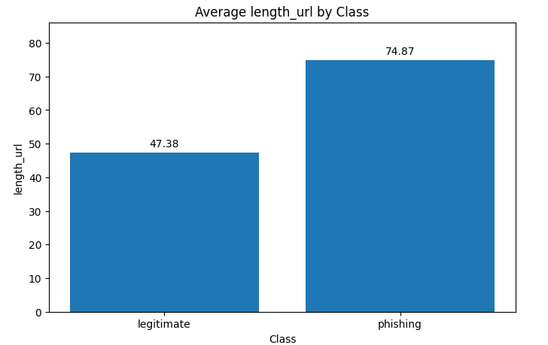
Another example of a significant difference between phishing and legitimate URLs is that the average page_rank was significantly higher for legitimate URLs (~ 4.48) than for phishing URLs (~ 1.89). Other features such as length_hostname exhibited a class difference in their average statistics as well but not nearly as stark (~ 23.7 for phishing URLs and ~ 18.5 for legitimate URLs). Differences such as these are helpful for machine learning models since they allow them to adequately distinguish between the classes.
In order to understand how linearly separable the two classes were, I did linear discriminant analysis (LDA) on all the features, resulting in the histogram below. As shown below, there is large degree of linear separability between the phishing and legitimate classes albeit with some overlap. This indicates that linear models such as Logistic Regression should do a good job at distinguishing between the classes provided that standardization is done beforehand.
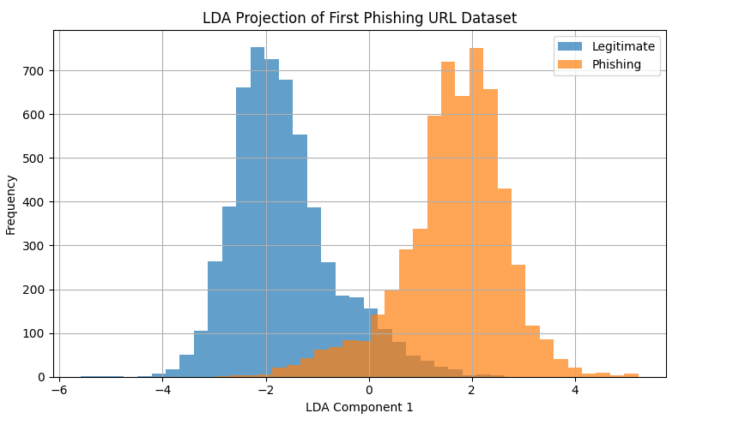
For the second phishing URL dataset, there was no need for either data cleaning or feature engineering. Just like with the first dataset, I investigated the relationship between class, 0 or legitimate and 1 for phishing, and the average values for each of the features. I found that there were significant differences in these average values by class for many of the features. A prime example of this was that phishing URLs had a length_url average value (~ 66.5) that was more than double that of the value for legitimate URLs (~ 23.6) as shown below.
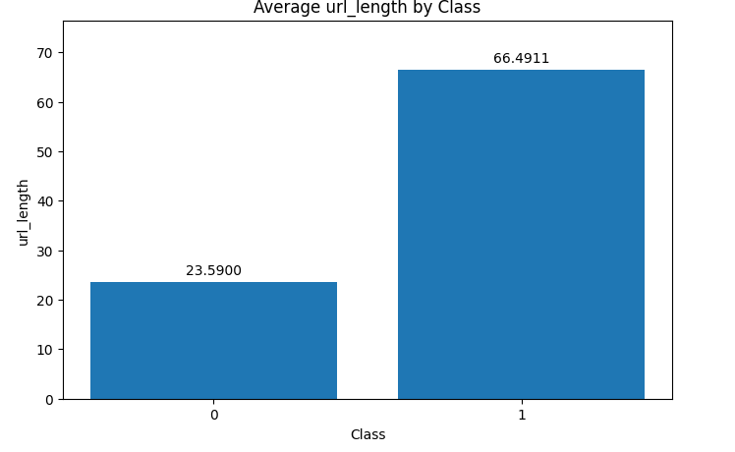
Significant differences were also evident for other features such as n_hypens (~ 0.66 for phishing URLs vs ~ 0.26 for legitimate URLs), n_underline (~ 0.30 for phishing URLs vs ~ 0.05 for legitimate URLs), and n_slash (~ 2.62 for phishing URLs vs ~ 0.29 for legitimate URLs). Differences such as these are sure to help machine learning models distinguish between the two classes.
To understand how linearly separable the two classes were, I did LDA on all the features, resulting in the histogram shown below. As shown below, there is substantial overlap between the classes as well as some amount of linear separability. This indicates that non-linear models such as Random Forest may be better at distinguishing between the two classes than linear models.
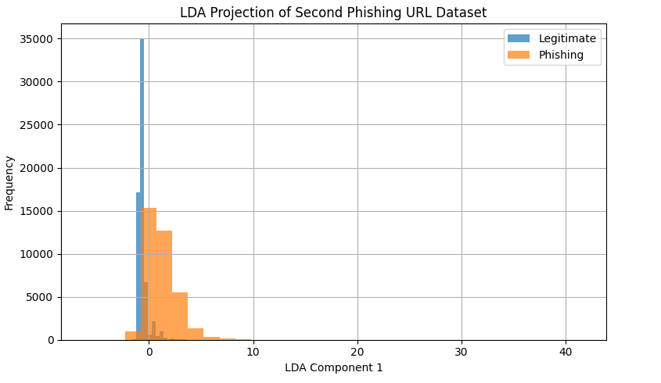
Unlike the first two datasets, the third dataset with phishing and legitimate emails needed data cleaning and feature engineering. The 16 missing values in the Email Text column had to be dropped in order to ensure that blank emails were not influencing model performance. Since, in its original form, this dataset had no features that would assist machine learning models aside from the Email Type column, new features had to created using the natural language processing technique (NLP) known as Term Frequency – Inverse Document Frequency or TF-IDF. This technique involves calculating the term frequency, the number of times a word or term appears in a document divided by the total number of words or terms in a document, and the inverse document frequency, the logarithm of the total number of documents divided by the number of documents containing a word or term and multiplying both these quantities (GeeksforGeeks). I utilized these techniques on the Email Text column and set the upper limit of features to 1000 to minimize both overfitting and the use of computational resources. I then did LDA on the dataset using these newly created features, resulting in the histogram below.
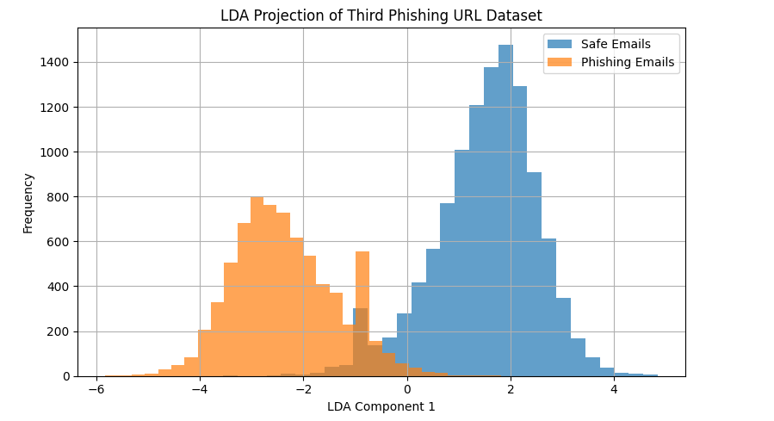
Based on what is shown in the histogram, it is evident that the two classes, phishing and safe emails, are very linearly separable with some amount of overlap. This indicates that linear models such as Logistic Regression should do a good job at distinguishing between the two classes.
Modeling and Analysis
For all three datasets, I utilized five classification models, each of which fell into the following categories: linear models, distance-based models, probabilistic models, tree models, and ensemble models. These models were as follows: Logistic Regression, K Nearest Neighbors (KNN), Bernoulli Naïve Bayes, Decision Tree, and Random Forest. The point of testing out these different types of models was to find out if there is a relationship between model type and overall performance. Logistic Regression itself served as a baseline for comparison.
Logistic Regression is a classification model that predicts the probability of a sample belonging to a particular class. It uses the sigmoid function to convert inputs into a probability value between 0 and 1 (GeeksforGeeks). The most common form of Logistic Regression, the one that was used in this project, is binomial Logistic Regression. This is used when a sample can only belong to one of two classes. Since the phishing detection project itself has only two classes, phishing and legitimate/safe, this makes sense. The reason why Logistic Regression is considered a linear model is that it uses the sigmoid function to transform the continuous outputs of the linear regression model into categorical outputs between 0 and 1 (GeeksforGeeks). Given that all three datasets show some significant level of linear separability, it makes sense to test Logistic Regression as a baseline before trying out the other non-linear models.
The K Nearest Neighbors classification algorithm operates by finding the “k” closest data points or neighbors to a sample and predicting the class of said sample based on the majority of its neighbors (GeeksforGeeks). It is known as a lazy learning algorithm because it does not learn from the training set immediately but stores the entire dataset and performs calculations only at the time of computation (GeeksforGeeks). It determines the nearest neighbors using the Minkowski distance metric, a family of metrics which includes the Euclidean distance metric (straight line distance) and the Manhattan distance metric (grid-like distance) (GeeksforGeeks). Obviously, the exact number of nearest neighbors as well as the choice of distance metric has a significant impact on how a sample is classified.
The Bernoulli Naïve Bayes algorithm is a variant of Naïve Bayes, an algorithm that uses Bayes’ Theorem to classify data based on the probabilities of different classes given the data’s input features (GeeksforGeeks). It is specifically meant for binary features. While the phishing URL datasets are not completely binary as far as features are concerned, given how many of the features have a large degree of sparsity as evident by many of their summary statistics being equal to or approximately equal to 0, their distribution is much closer to that of a binary distribution than that of a standard continuous distribution. Therefore, Bernoulli Naïve Bayes makes more sense to use than other variants such as Gaussian or Multinomial.
The Decision Tree classification algorithm decides how to classify samples by asking a series of “Yes/No” questions (GeeksforGeeks). This has the effect of splitting the data into subsets based on specific attributes. Eventually these subsets, also known as nodes, become smaller and smaller until there are no more useful questions to ask, leading to a final prediction (GeeksforGeeks). The algorithm decides how to split the nodes based on either Gini impurity, a measure of how impure a node is, and entropy, a measure of the amount of uncertainty or disorder in the data (GeeksforGeeks). The whole point is to create small samples that are very homogenous as far as class is concerned, enabling easy prediction.
The Random Forest algorithm uses many decision trees to make predictions (GeeksforGeeks). Each tree looks at different random parts of the data and their results are combined, culminating in a majority vote for the class (GeeksforGeeks). Compared to the ordinary Decision Tree algorithm, there is less chance of overfitting and large datasets are more adequately dealt with. Random Forest is considered an ensemble model because of its combination of simpler models. Given this reality, it was expected to exceed or at least match the performance of baseline Logistic Regression.
For all three datasets, I used all numerical features as inputs and the phishing category as the output. I also utilized both train test split and cross validation to ensure that the entire dataset was not used for evaluation, reducing the potential for overfitting in the process. I did train test split using the ratio of 80 – 20 and set the number cross-validation folds to 5. For the second and third datasets, I did stratify = y for the test train split to account for the class imbalance present in both. This would ensure that the class balance in both datasets would be reflected in the testing set. The evaluation metrics I used were test and cross validation accuracy as well as the phishing f1 score. Accuracy would measure the total percentage of samples that were correctly categorized while the phishing f1 score would approximate how well the model classified phishing samples. As was already mentioned, the threshold for success was set at 80% or higher for all these metrics. As far as hyperparameter tuning was concerned, I utilized GridSearchCV. The hyperparameters I varied depended significantly on the model in question.
For Logistic Regression, I varied the C, penalty, and solver hyperparameters. The C parameter was the inverse of regularization strength; the larger the value, the less regularization occurred (scikit-learn). The penalty was the type of regularization that was done. This could be either L1, L2, none, or ElasticNet (combination of L1 and L2) (scikit-learn). The solver was the algorithm to use for optimization. Some examples include liblinear, saga, and newton-cholesky (scikit-learn). For K Nearest Neighbors, I varied the n_neighbors, p, and weights hyperparameters. The n_neighbors was the number of neighbors used to determine who the nearest neighbors were (scikit-learn). The p was the power parameter of the Minkowski metric. When set to 1, it would be equal to the Manhattan metric and set to 2, it would be equal to the Euclidean metric (scikit-learn). The weights was the weight function used in prediction. This could either be uniform (all points are weighed equally), distance (points weighed by inverse of distance) or user created (scikit-learn). For Bernoulli Naïve Bayes, I varied the alpha and fit prior hyperparameters. The alpha was the additive Laplace parameter (scikit-learn). Fit-prior determined whether to learn class prior probabilities (scikit-learn). For Decision Tree, I varied the criterion and max_depth hyperparameters. The criterion was the function used to measure the quality of the split (scikit-learn). Common examples included Gini impurity and entropy. Max_depth was the maximum depth of the tree (scikit-learn). For Random Forest, I varied the n_estimators, max_depth, and bootstrap hyperparameters. N_estimators was the number of trees in the forest (scikit-learn). Bootstrap was whether bootstrap samples ought to be used when building trees.
For the first two URL datasets, I utilized Standard Scaler for the first two models, Logistic Regression and KNN, after doing train test split given the substantially different ranges for each of the numerical features, something that can significantly hamper performance if not adequately addressed. For the last three models, Bernoulli Naïve Bayes, Decision Tree, and Random Forest, this wasn’t necessary since the scale of the features isn’t as essential. For the third email dataset, I created TF-IDF features for all of the models since there were previously no features that the models could learn from aside from email type. When doing this, I included a stop_words = “english” parameter, filtering out commonly used low meaning words (i.e. and, but, or) as well as a max_features restriction of 1000 to reduce both overfitting and the use of computational resources. To help minimize the possibility of data leakage, I did this after test train-split was already done. There was no need to do Standard Scaler with any of these features since the default settings of the sklearn TF-IDF library already normalizes the feature vectors to be in the range of 0 to 1. However, given that max_features was set to 1000, the KNN model would potentially struggle with classification. This is because of both high dimensionality (distances are harder to differentiate in high dimensional space) as well as the sparsity of the data (TF-IDF vectors often contain many 0s since many words can be present in some emails but not in others). Because of this, I utilized dimensionality reduction in the form of principal component analysis or PCA for the KNN model, setting the number of n_components to 100. This in effect meant that I was selecting the top 100 principal components that captured 1000 TF-IDF features worth of information. Lastly, since the second and third datasets had a class imbalance favoring non-phishing samples, I set the class_weight parameter in available models (Decision Tree, Logistic Regression, Random Forest) to balanced. That way, high accuracy would not be obtained by just successfully predicting the majority class at the expense of the minority class, phishing.
Results
After all of the preprocessing, train test split, cross validation, and hyperparameter tuning was done as mentioned above, I tabulated the best performance of all models and displayed it using column bar charts. For the first dataset, the baseline Logistic Regression model performed very well, getting a test accuracy of approximately 96%, a cross-validation accuracy of approximately 94%, and a phishing f1 score of 96%. The KNN model performed somewhat better, getting roughly the same test accuracy and phishing f1 score but a higher cross validation accuracy score of approximately 95%. Random Forest did better than both Logistic Regression and KNN, getting test and cross validation accuracy scores approximately equal to 97% as well as a phishing f1 score of 97%. In contrast, Decision Tree did worse than Logistic Regression, getting test and cross validation accuracy scores approximately equal to 94% and a phishing f1 score of 93%. Bernoulli Naïve Bayes did worst of all, getting test and cross validation accuracy scores of approximately 88% as well as a phishing f1 score of 88%. However, it still met the success criteria since the results were above 80%.
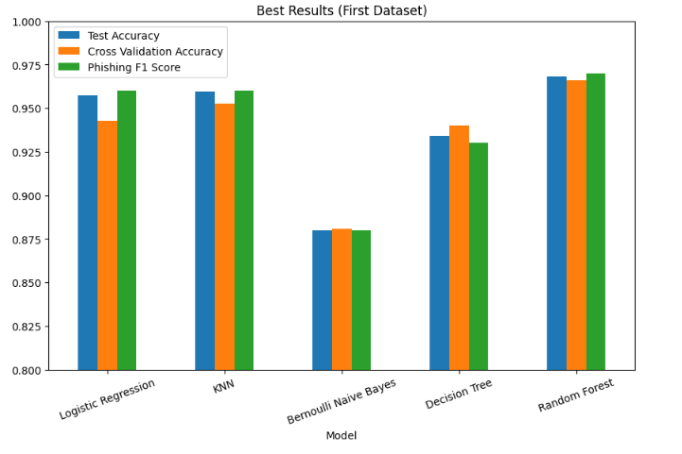
For the second dataset, the baseline Logistic Regression model did substantially worse than it did for the first dataset, getting test and cross validation accuracy scores of just approximately 86% and a phishing f1 score of just 80%. KNN did better, getting test and cross validation accuracy scores of approximately 89% and a phishing f1 score of 84%. Random Forest did better than Logistic Regression as well, getting roughly the same test and cross-validation accuracy scores and a higher phishing f1 score of 85%. Decision Tree did somewhat worse than Random Forest, getting test and cross-validation accuracy scores of approximately 88% alongside the same phishing f1 score of 85%. However, it still did better than Logistic Regression. It was only Bernoulli Naïve Bayes that did worse than Logistic Regression. It got test and cross validation accuracy scores of approximately 83% and 84% respectively and a phishing f1 score of 79%. Since the last number fell below the 80% benchmark, Bernoulli Naïve Bayes failed to meet the success criteria. It is noteworthy that no model scored in the 90 percent range, something that could be due in significant part to class imbalance.
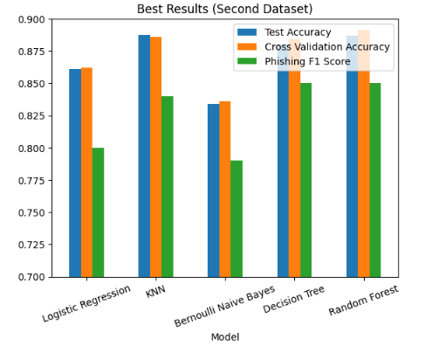
For the third dataset, baseline Logistic Regression got results that were much closer to those of the first dataset, getting a test and cross validation accuracy scores that were approximately 95% and a phishing f1 score of 94%. KNN did worse, getting test and cross validation accuracy scores of approximately 93% and 92% respectively and a phishing f1 score of 91%. Decision Tree did even worse, getting test and cross validation accuracy scores of approximately 90% and 91% respectively and a phishing f1 score of 88%. Just like with the other two datasets, Bernoulli Naïve Bayes performed the worst of all, getting test and cross-validation accuracy scores of approximately 88% and 87% respectively as well as a phishing f1 score of 86%. The only model that didn’t perform worse than Logistic Regression was Random Forest; it got test and cross validation accuracy scores of approximately 95% and 96% respectively and a phishing f1 score of 94%. Since Random Forest is the only model that performed better or at least approximately equal to the baseline model of Logistic Regression for all three datasets, one has to conclude that it along with Logistic Regression is best suited for phishing detection. The reason for this is that Logistic Regression is already an obvious choice for phishing detection since it gets high results that are well above the 80% benchmark for all three datasets even though it was a simple linear binary classification model. Therefore, a model like Random Forest that consistently does better than or at least matches this baseline model for all three datasets is clearly a suitable addition. While it is true that the other non-linear models with the exception of Bernoulli Naïve Bayes exceeded the 80% benchmark, the fact that they did not consistently outperform or match the baseline Logistic Regression model for all three datasets indicates that they are not as reliable for phishing detection. Since Random Forest is an ensemble model, this suggests that ensemble models are more suitable than other non-linear alternatives to Logistic Regression. These models will make avoiding falling for phishing attempts easier than other models would.
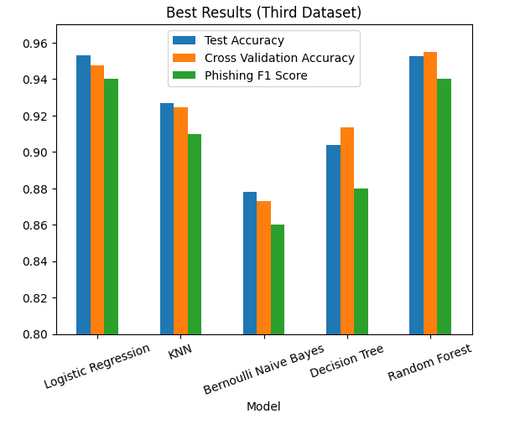

Recommendations
Based on these findings, it is recommended to use Random Forest or some other ensemble model (i.e. XGBoost) in addition to Logistic Regression for phishing detection given that it was only this category of model that performed better or approximately equal to the baseline for all three datasets. That said, there are a few things that should be accounted for. One of them is the necessity of appropriate preprocessing steps before model deployment. These include feature scaling and feature engineering. Feature scaling involves using techniques such as standardization to mitigate the impact of differences in scale between features. This is needed for Logistic Regression but not so much for models such as Random Forest that are scale invariant. Feature engineering involves the creation of new features that can better reflect the differences between the classes, in this case, phishing and non-phishing. The email dataset was in dire need of this because no features existed aside from email text and email type that models could learn from. If one decides to use the email dataset or others like it, it would be necessary to experiment with various features that are created using TF-IDF or other methods. If one is using TF-IDF, one can vary parameters such as max_features to see how that impacts performance metrics, taking into account computational resources of course.
The other thing that should be considered is the ratio of phishing to non-phishing samples in the real world. This ratio could be very different from that of the three datasets. The last thing one should want is for a model to get a high accuracy score overall but fail to adequately predict phishing samples because of how infrequent they are. To address this, it will be necessary to set class_weight parameters within models to “balanced” or do other class balancing techniques such as the Synthetic Minority Over-sampling Technique (SMOTE). Once all these things are taken into account, business and organizations are sure to experience the benefits of improved phishing detection such as saved time and money.

AI Appendix
I did not use any AI tools for this assignment in order to ensure that everything reflects my work alone.

Works Cited
Kosinski, M. (2024, May 17). What is Phishing? IBM. https://www.ibm.com/think/topics/phishing
Web page Phishing Detection Dataset. Kaggle. https://www.kaggle.com/datasets/shashwatwork/web-page-phishing-detection-dataset
Phishing Email Detection. Kaggle. https://www.kaggle.com/datasets/subhajournal/phishingemails
Web Page Phishing Dataset. Kaggle. https://www.kaggle.com/datasets/danielfernandon/web-page-phishing-dataset
GeeksforGeeks. (2021, January 20). Understanding TFIDF (Term Frequency Inverse Document Frequency). GeeksforGeeks. https://www.geeksforgeeks.org/machine-learning/understanding-tf-idf-term-frequency-inverse-document-frequency/
GeeksforGeeks. (2017, May 9). Logistic Regression in Machine Learning. GeeksforGeeks. https://www.geeksforgeeks.org/machine-learning/understanding-logistic-regression/
‌scikit-learn. (2014). LogisticRegression. Scikit-Learn.org. https://scikit-learn.org/stable/modules/generated/sklearn.linear_model.LogisticRegression.html

GeeksforGeeks. (2017, April 14). KNearest Neighbor(KNN) Algorithm. GeeksforGeeks. https://www.geeksforgeeks.org/machine-learning/k-nearest-neighbours/
‌

scikit-learn. (2019). sklearn.neighbors.KNeighborsClassifier — scikit-learn 0.22.1 documentation. Scikit-Learn.org. https://scikit-learn.org/stable/modules/generated/sklearn.neighbors.KNeighborsClassifier.html
GeeksforGeeks. (2017, March 3). Naive Bayes Classifiers. GeeksforGeeks. https://www.geeksforgeeks.org/machine-learning/naive-bayes-classifiers/
‌sklearn.naive_bayes.BernoulliNB. Scikit-Learn. https://scikit-learn.org/stable/modules/generated/sklearn.naive_bayes.BernoulliNB.html
GeeksforGeeks. (2017, October 16). Decision Tree. GeeksforGeeks. https://www.geeksforgeeks.org/machine-learning/decision-tree/
‌scikit-learn. (2019). sklearn.tree.DecisionTreeClassifier — scikit-learn 0.22.1 documentation. Scikit-Learn.org. https://scikit-learn.org/stable/modules/generated/sklearn.tree.DecisionTreeClassifier.html
GeeksforGeeks. (2024, February 22). Random Forest Algorithm in Machine Learning. GeeksforGeeks. https://www.geeksforgeeks.org/machine-learning/random-forest-algorithm-in-machine-learning/
Scikit-Learn. (2025). sklearn.ensemble.RandomForestClassifier — scikit-learn 0.20.3 Documentation. Scikit-Learn.org. https://scikit-learn.org/stable/modules/generated/sklearn.ensemble.RandomForestClassifier.html

